PROBLEM 3.21

KNOWN: Thickness, overall temperature difference, and pressure for two stainless steel plates.

FIND: (a) Heat flux and (b) Contact plane temperature drop.

SCHEMATIC:
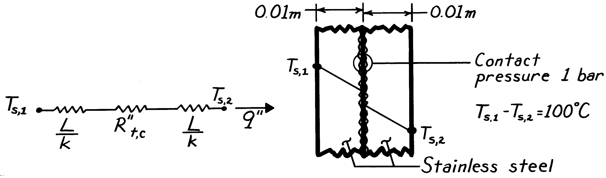

ASSUMPTIONS: (1) One-dimensional heat transfer, (2) Steady-state conditions, (3) Constant properties.

PROPERTIES: Table A-1, Stainless Steel (T ≈ 400K): k = 16.6 W/m⋅K.

ANALYSIS: (a) With 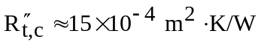 from Table 3.1 and

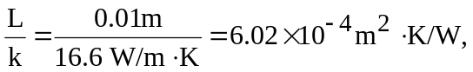

it follows that

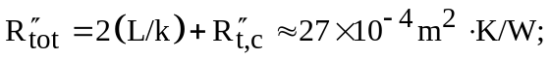

hence

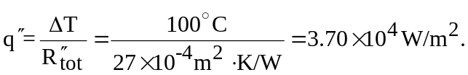 <

(b) From the thermal circuit,

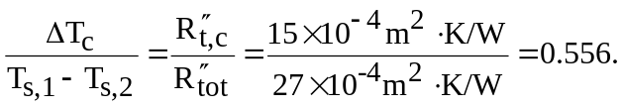

Hence,

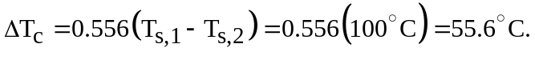 <

COMMENTS: The contact resistance is significant relative to the conduction resistances. The value of 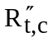 would diminish, however, with increasing pressure. Note that there is considerable uncertainty in the answer since the thermal contact resistance can take on a wide range of values.

